Prasar Srivastava  
22BCE10841  
AWS CLOUD Architect CSE3016  
Submitted To-Dr. Munsifa Firdaus Khan  
Lab 1

THE CONSOLE PAGE WILL APPEAR

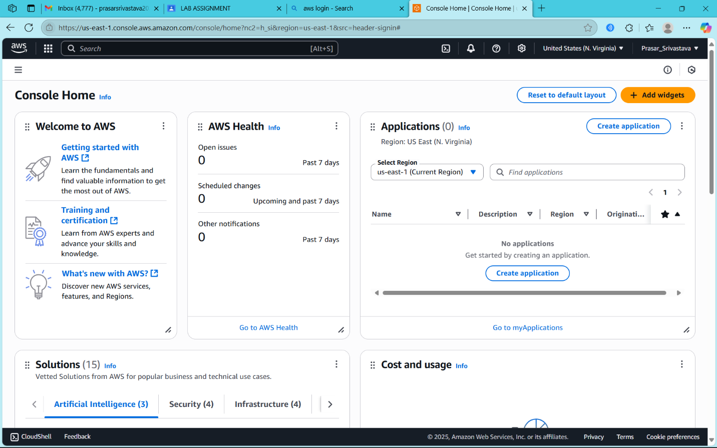

SEARCH/CLICK ON IAM

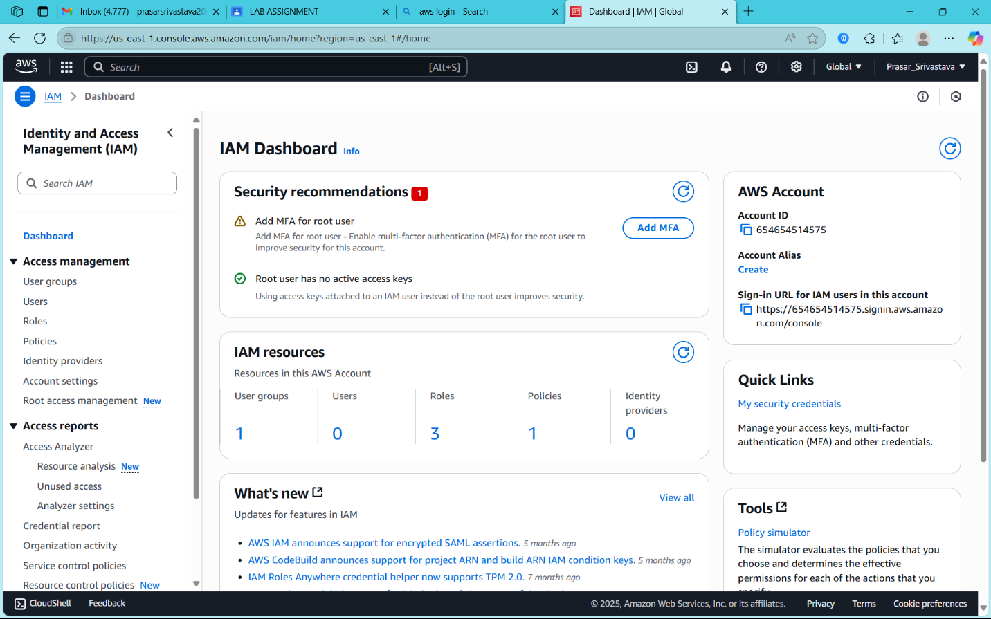

CLICK ON USER

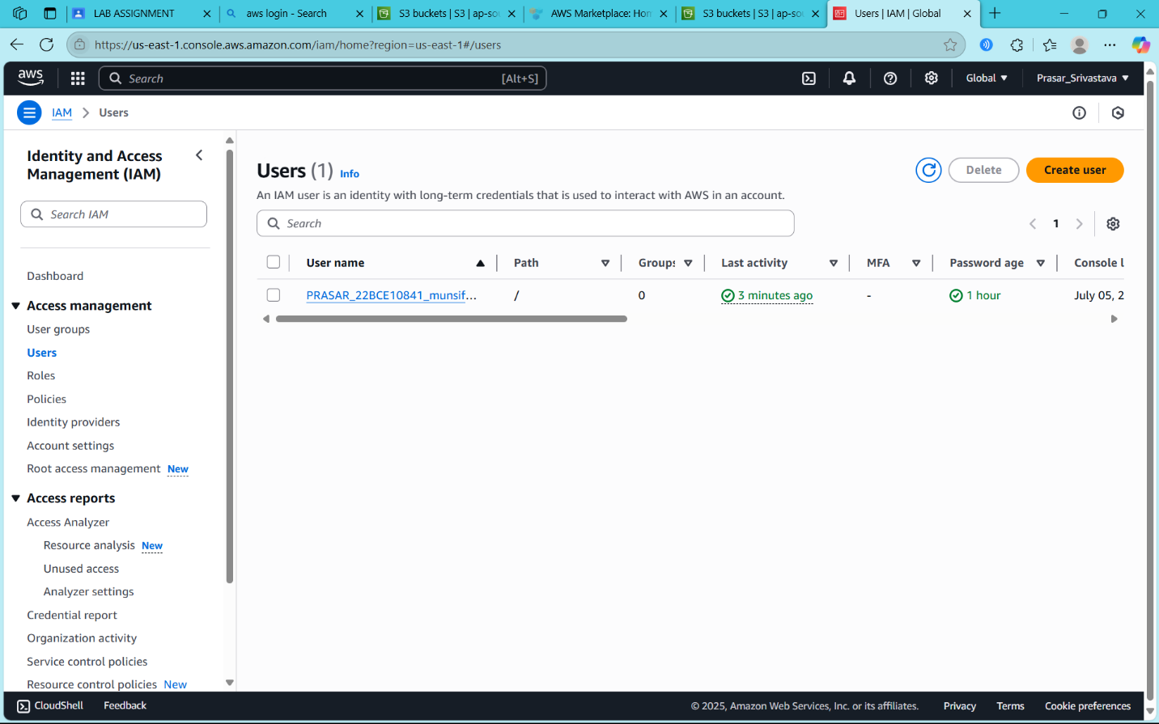

CLICK ON ADD USER TO GROUP AND CREATE GROUP

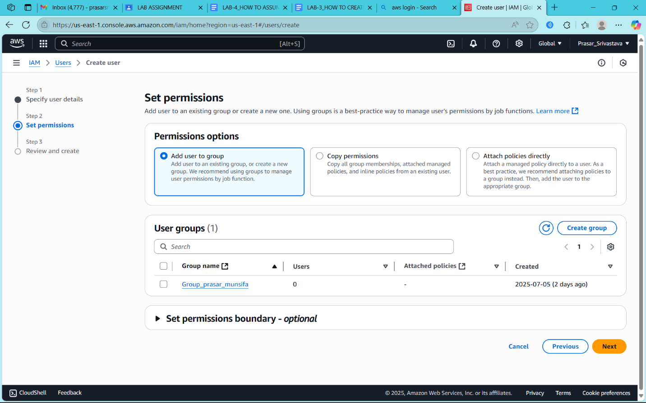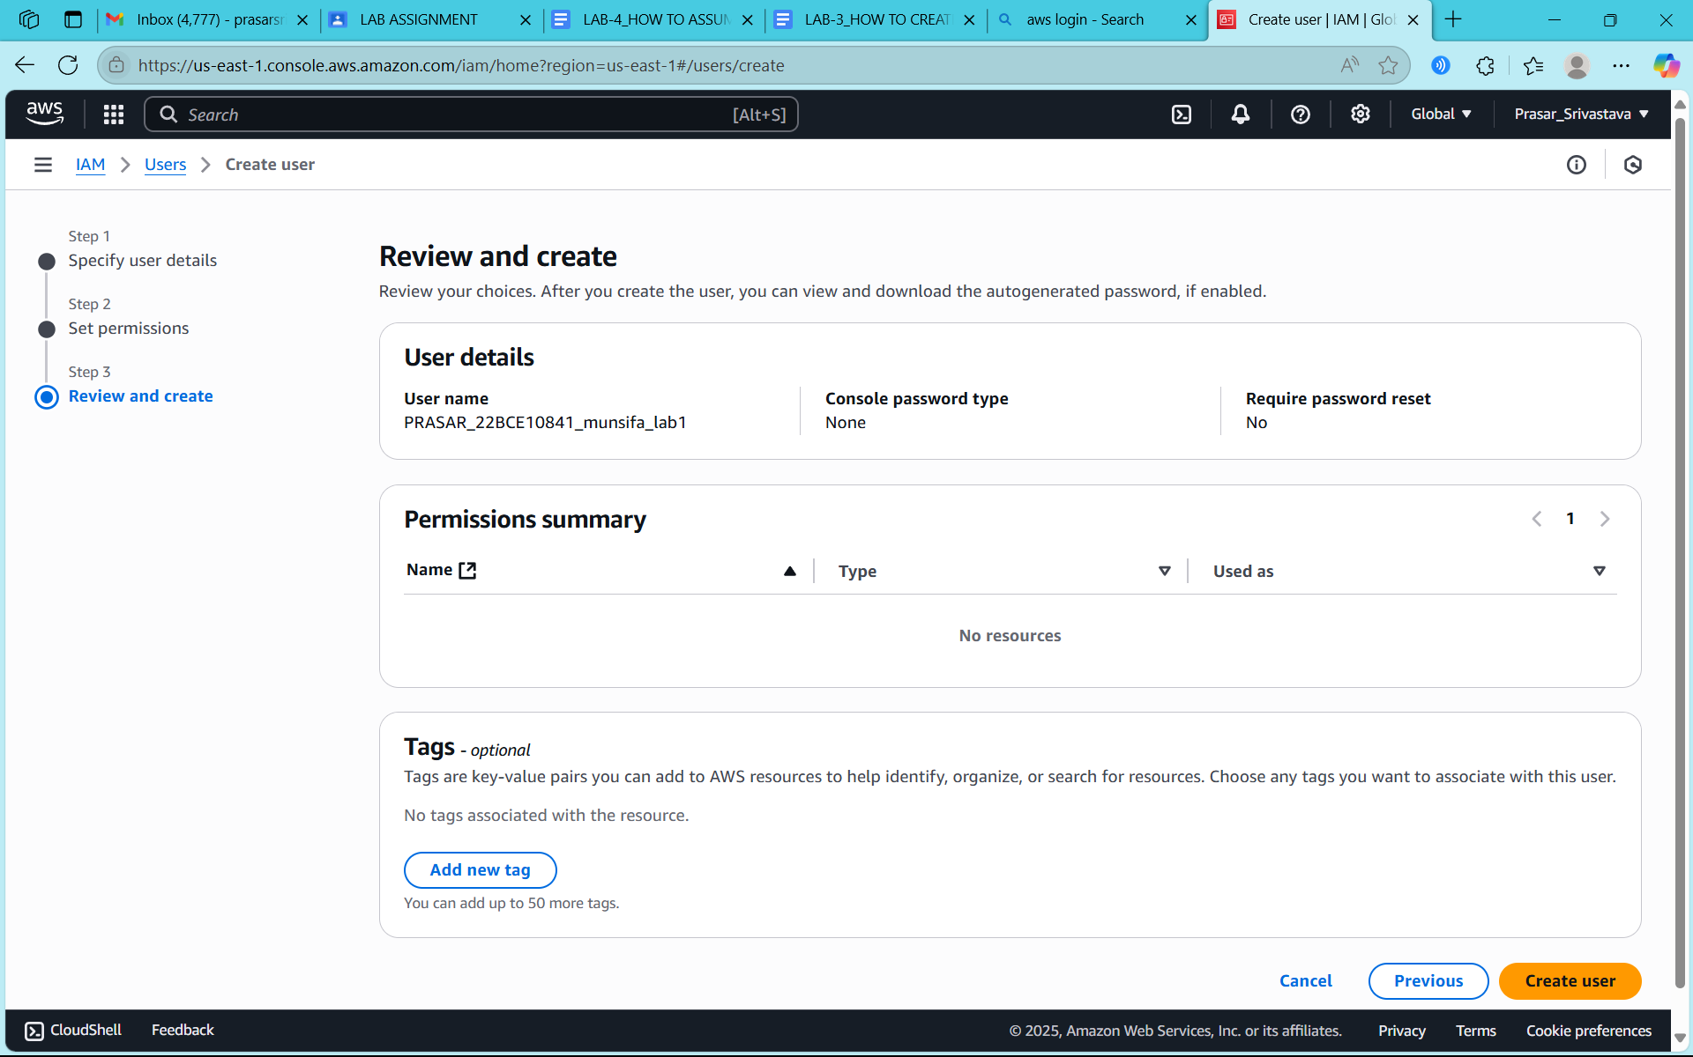

CLICK ON CREATE USER

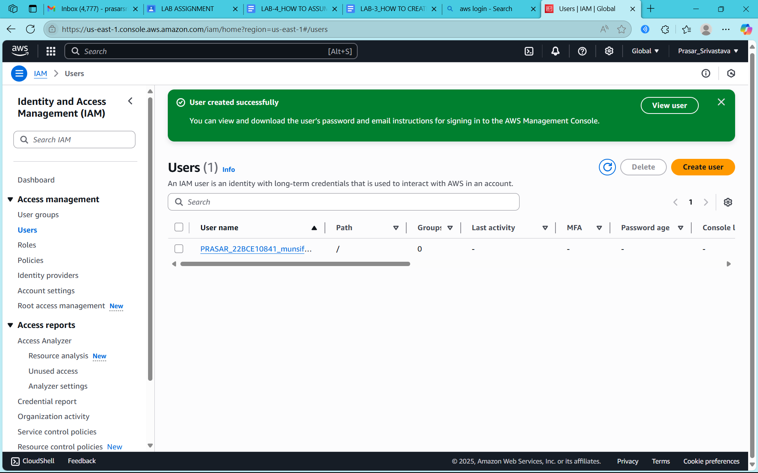

CLICK ON **PRASAR_22BCE10841_munsifa_lab1** to see the details of the IAM user

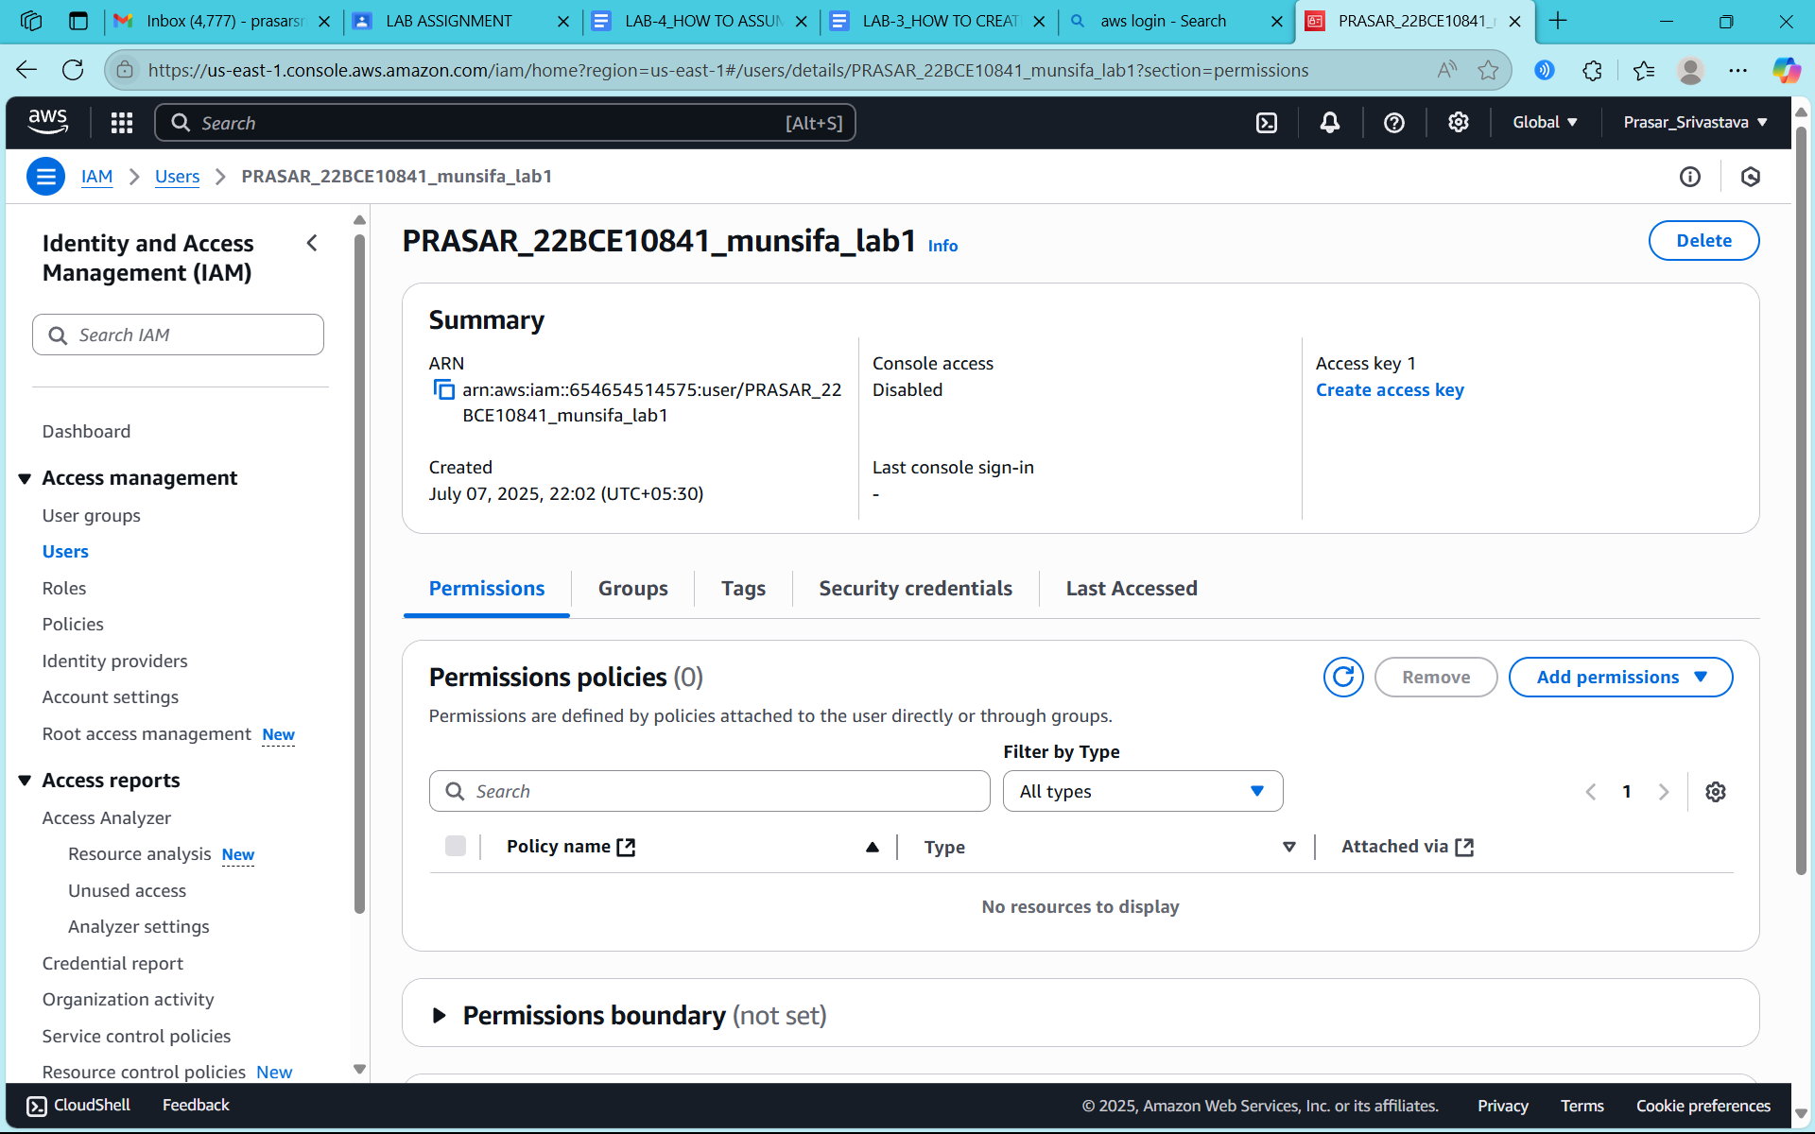

**CLICK ON SECURITY CREDENTIALS**

**CLICK ON ENABLE CONSOLE ACCESS**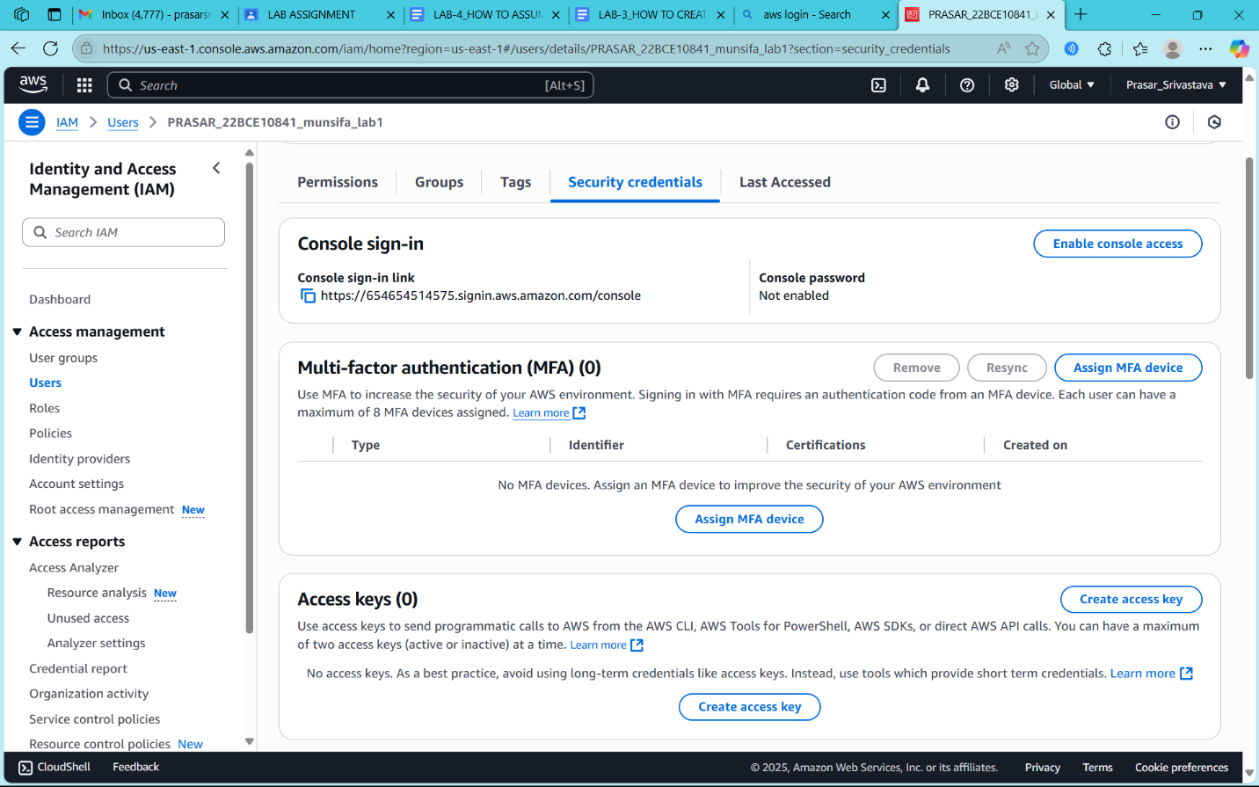

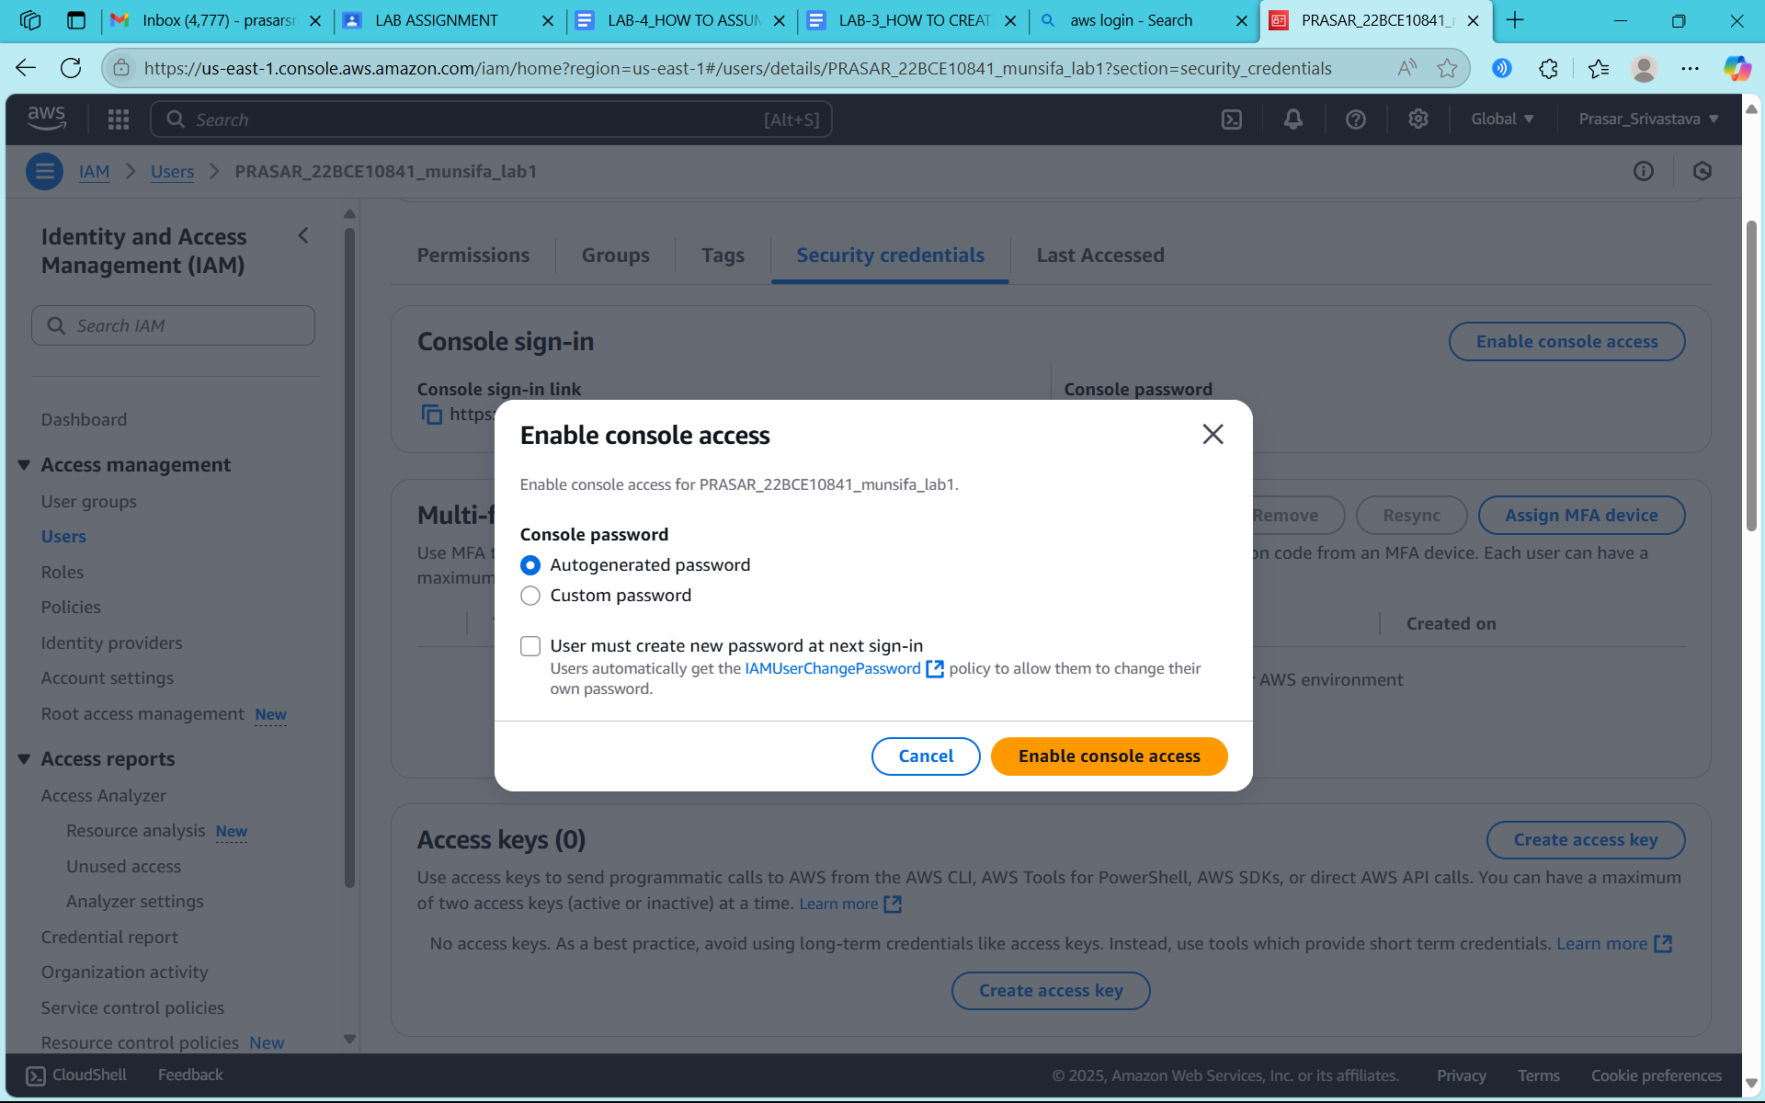

**STEP15: COPY THE INFORMATION ON SEPARATE FILE AND CLICK ON CLOSE**

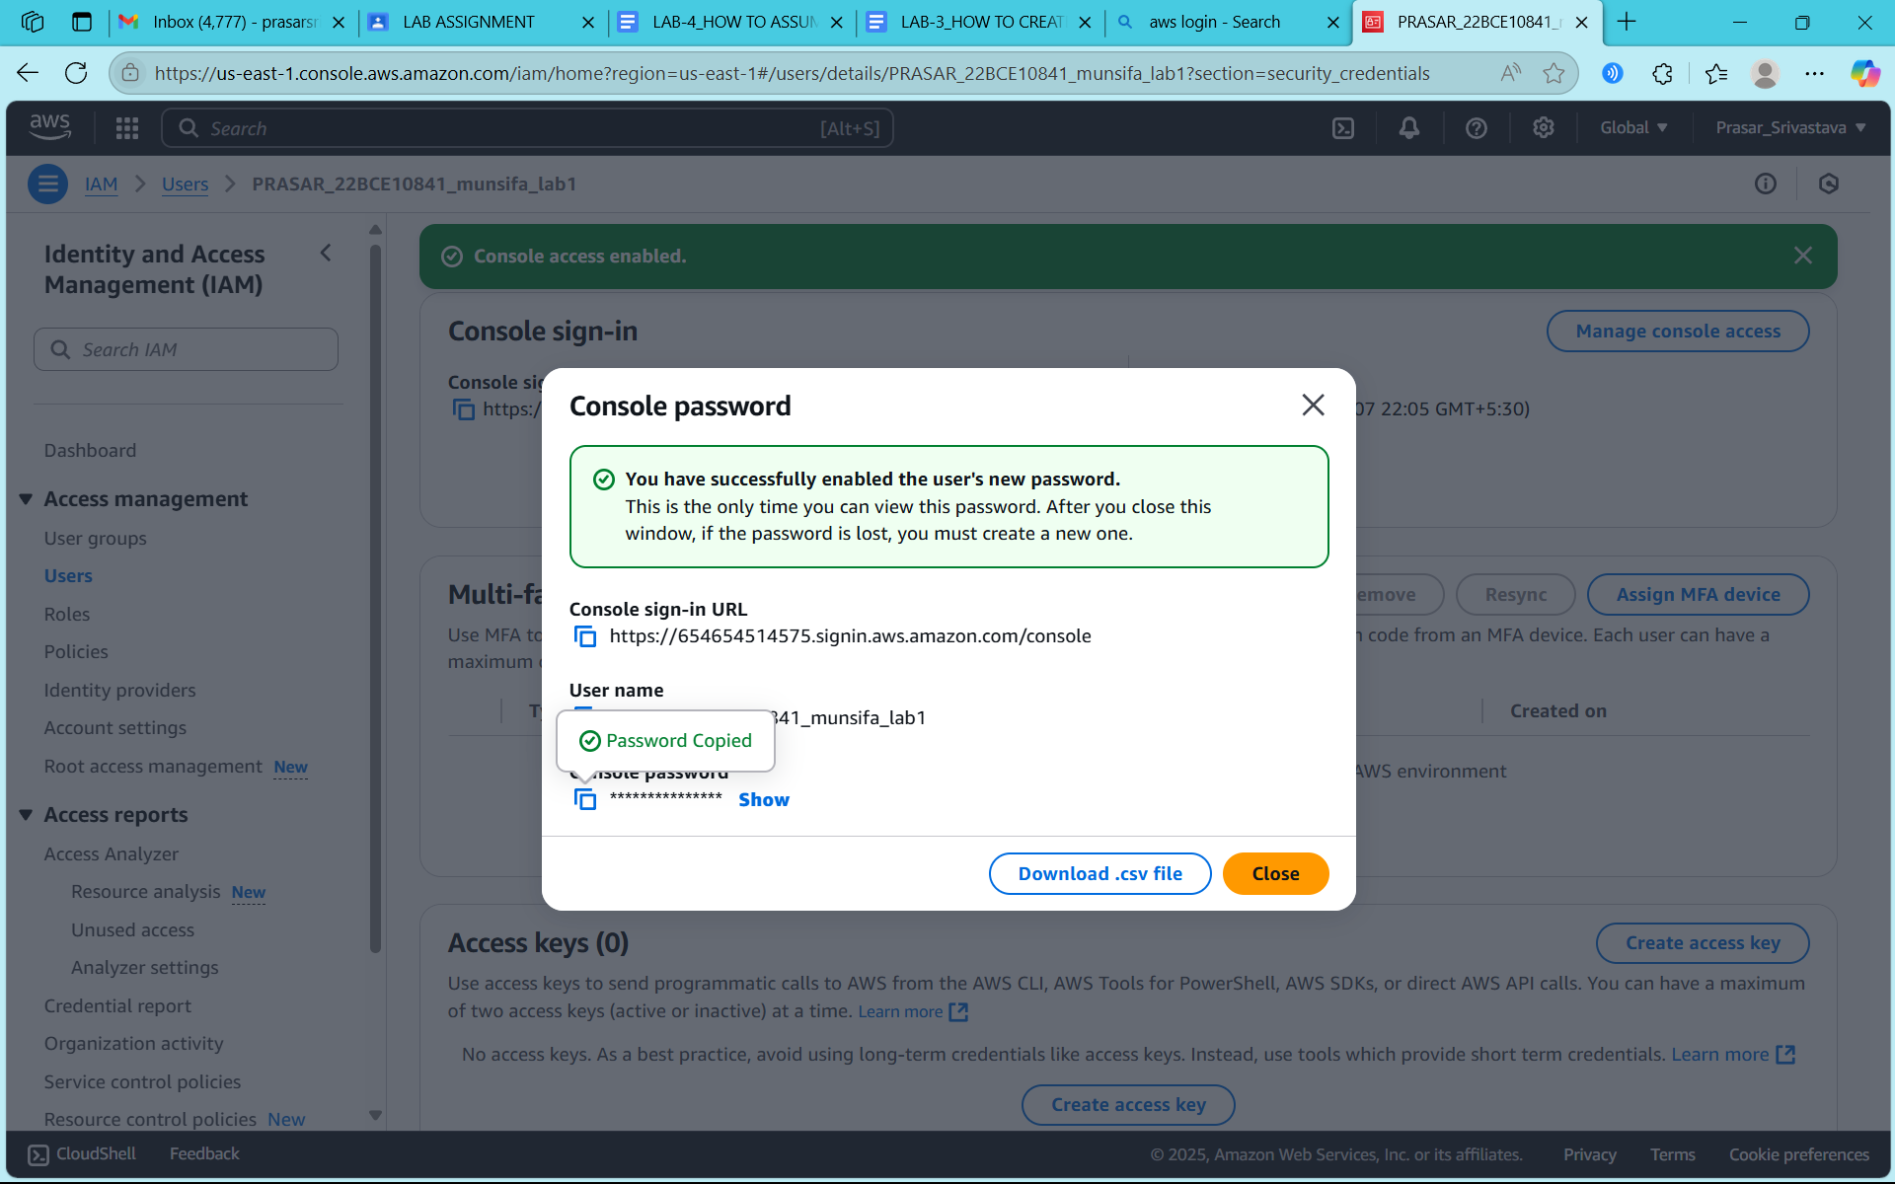

**STEP16: OPEN SEPARATE WINDOW AND COPY THE LINK TO OPEN IAM USER**

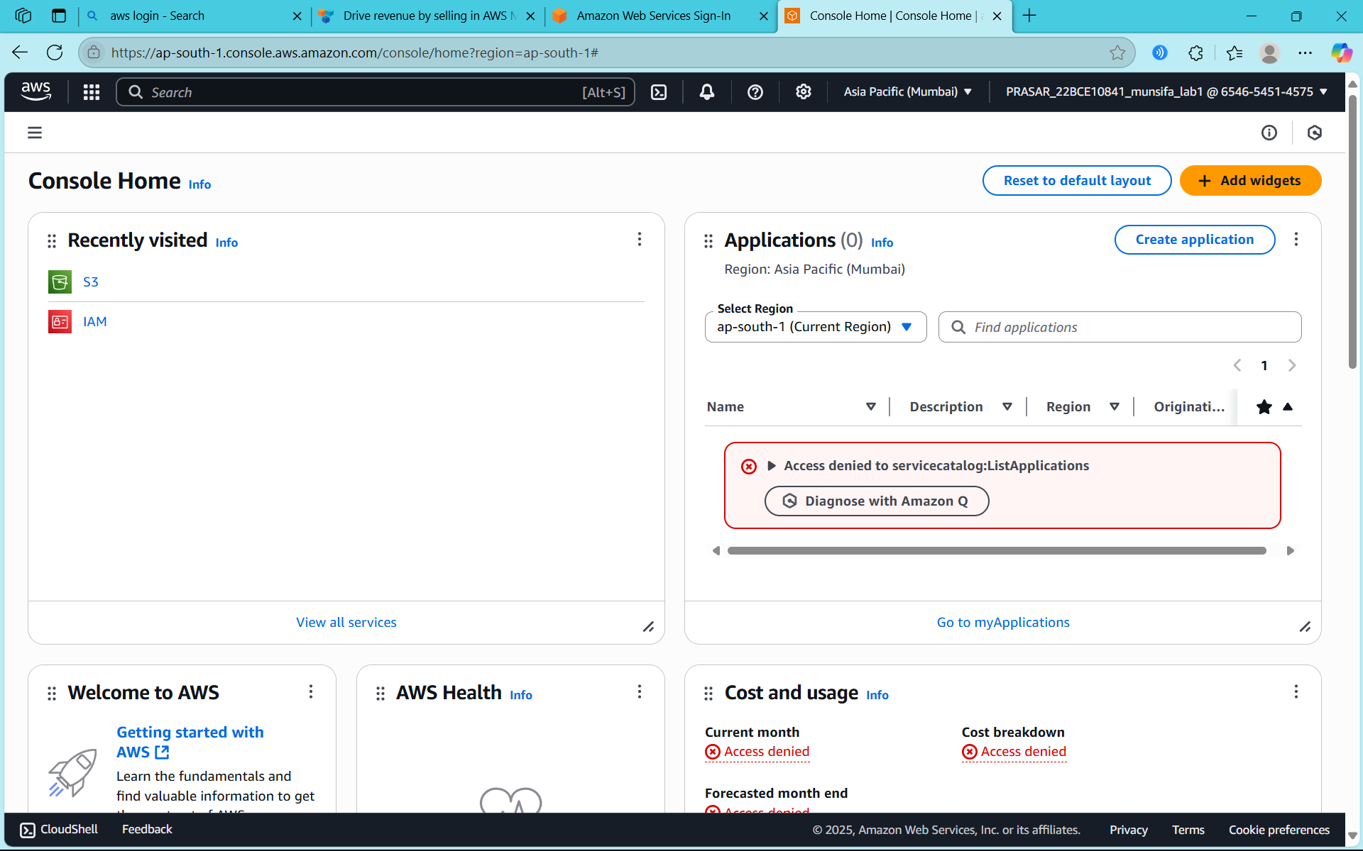

**STEP17: IAM USER CONSOLE PAGE WILL APPEAR**



**STEP18: CLICK ON S3**

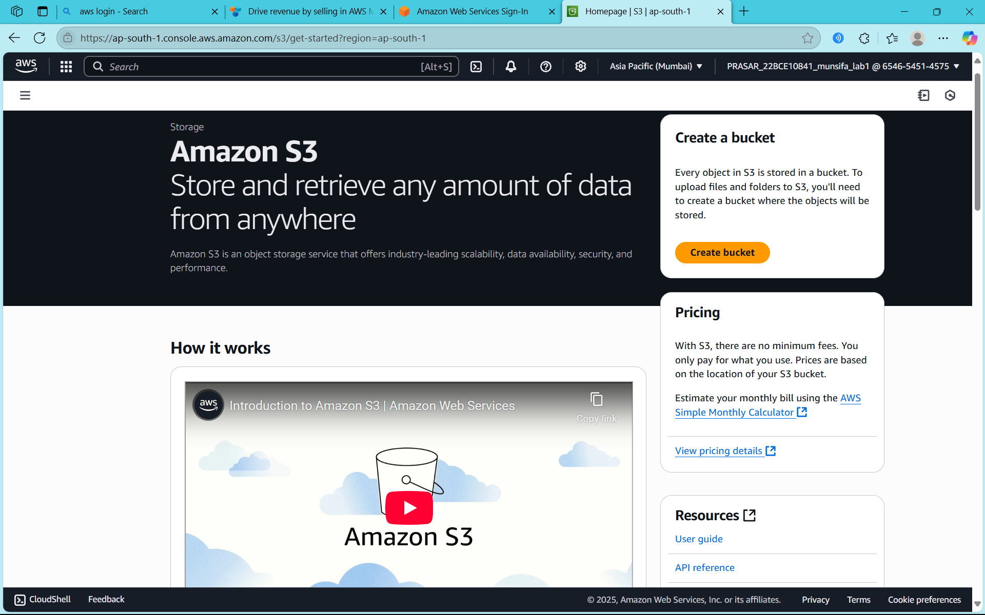

**STEP18: CLICK ON GENERAL PURPOSE BUCKET**

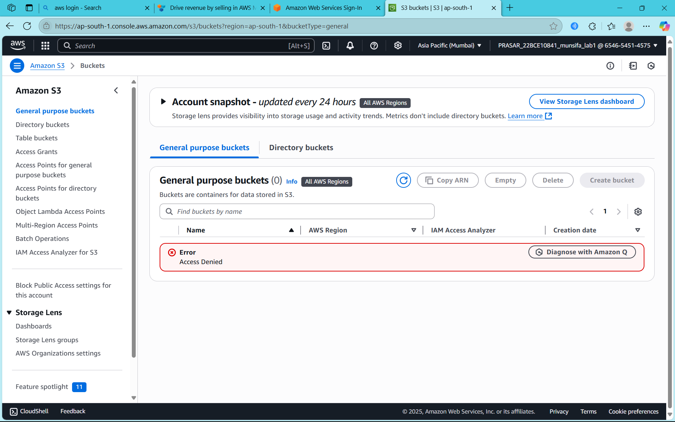

**STEP19: AN ERROR WILL APPEAR**

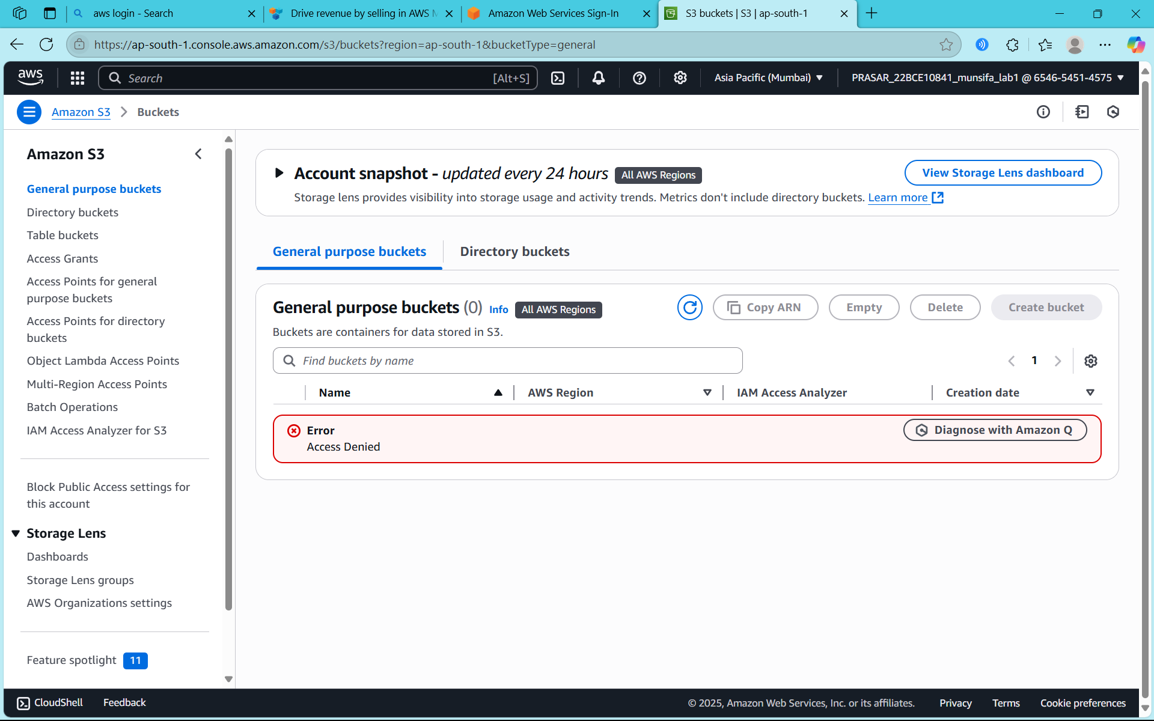

**STEP20: WE NEED TO CREATE POLICIES FROM ROOT USER, CLICK ON CREATE POLICY**

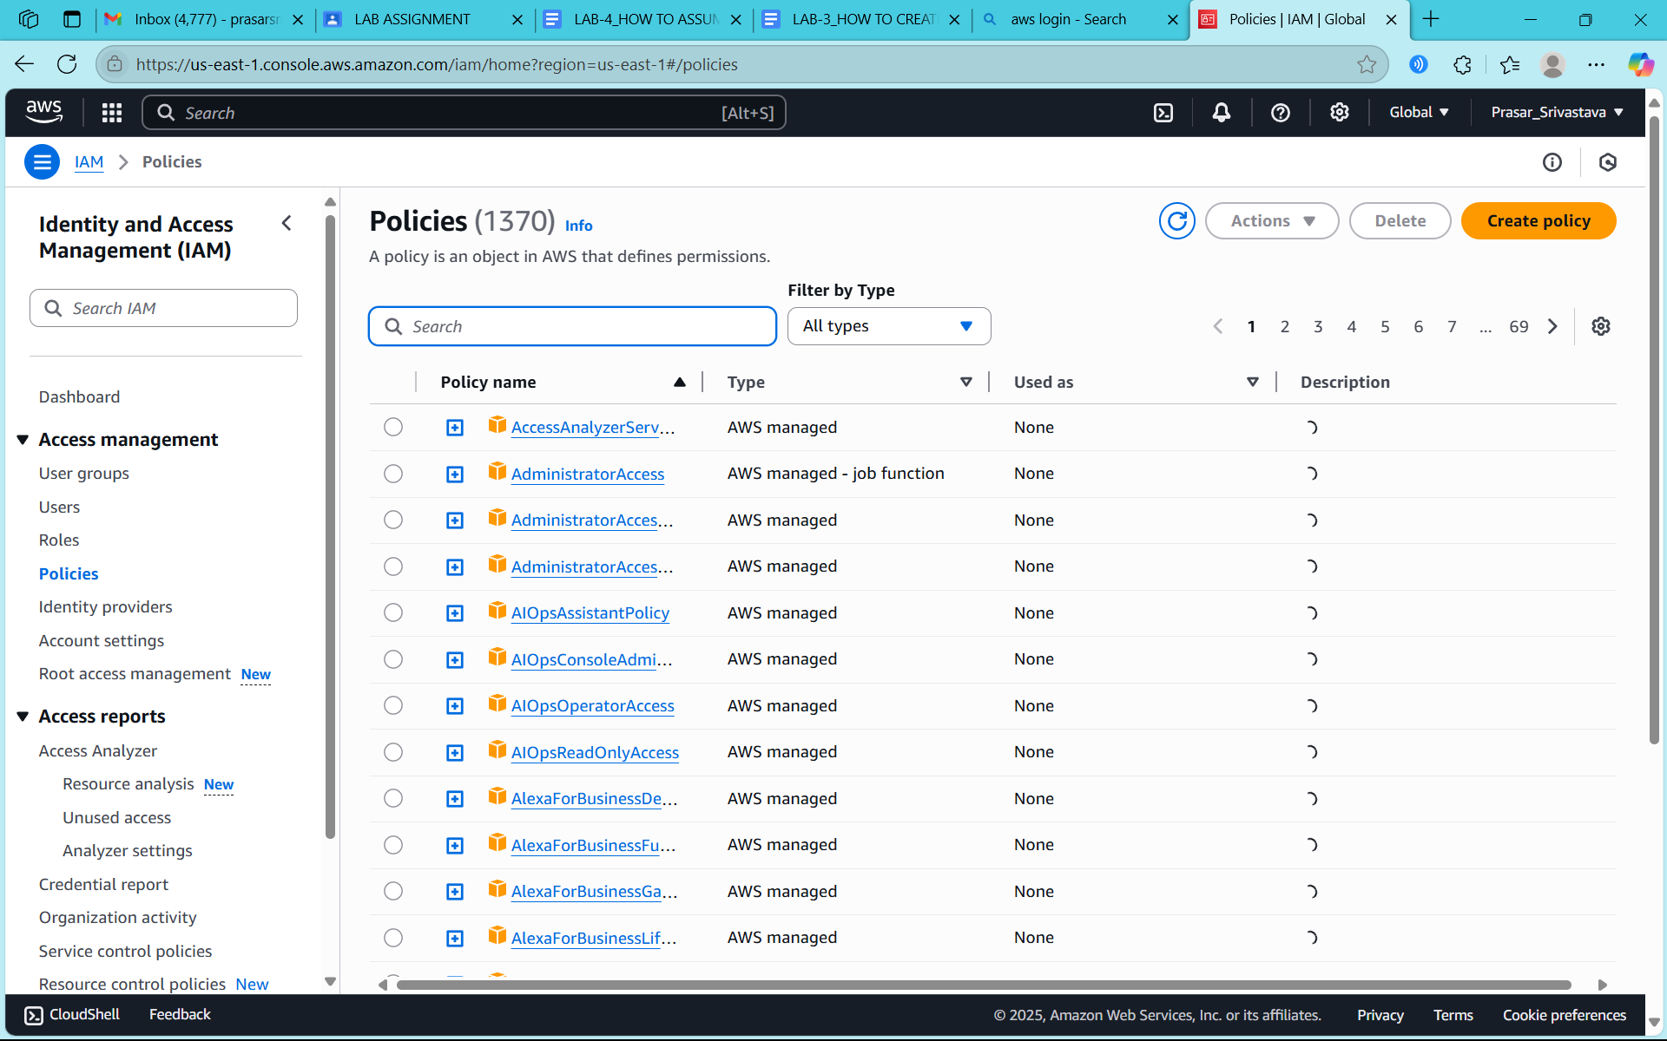

**STEP21: CLICK ON JSON TAB AND MODIFY THE FOLLOWING CODE**

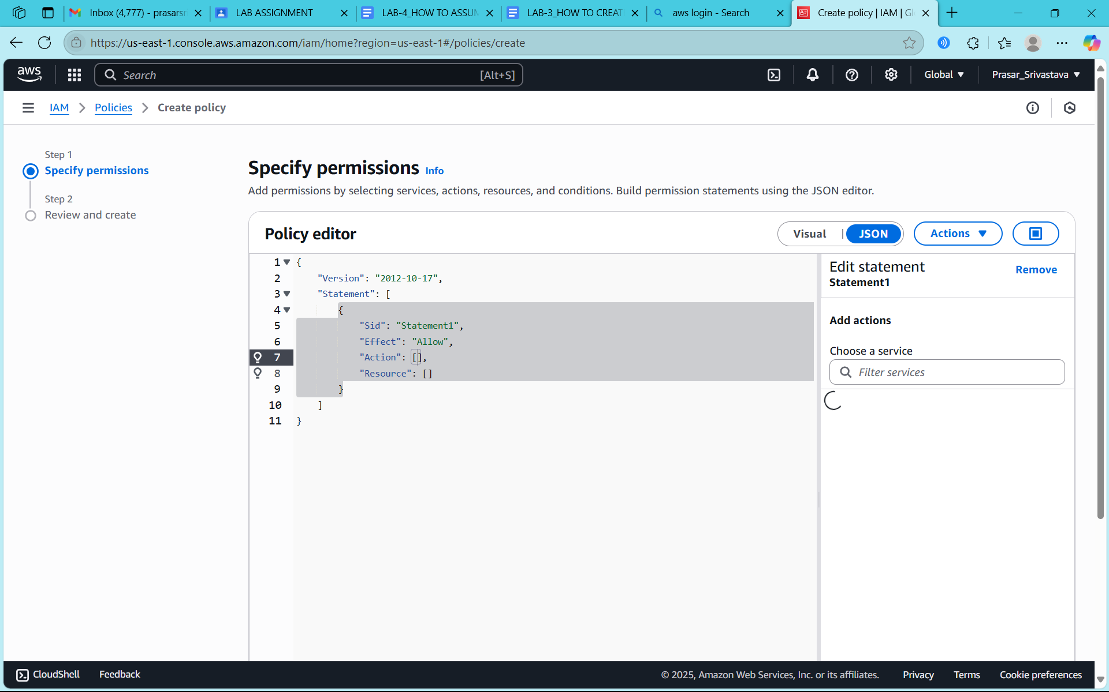

**STEP22: WRITE THE FOLLOWING CODE AND CLICK ON NEXT**

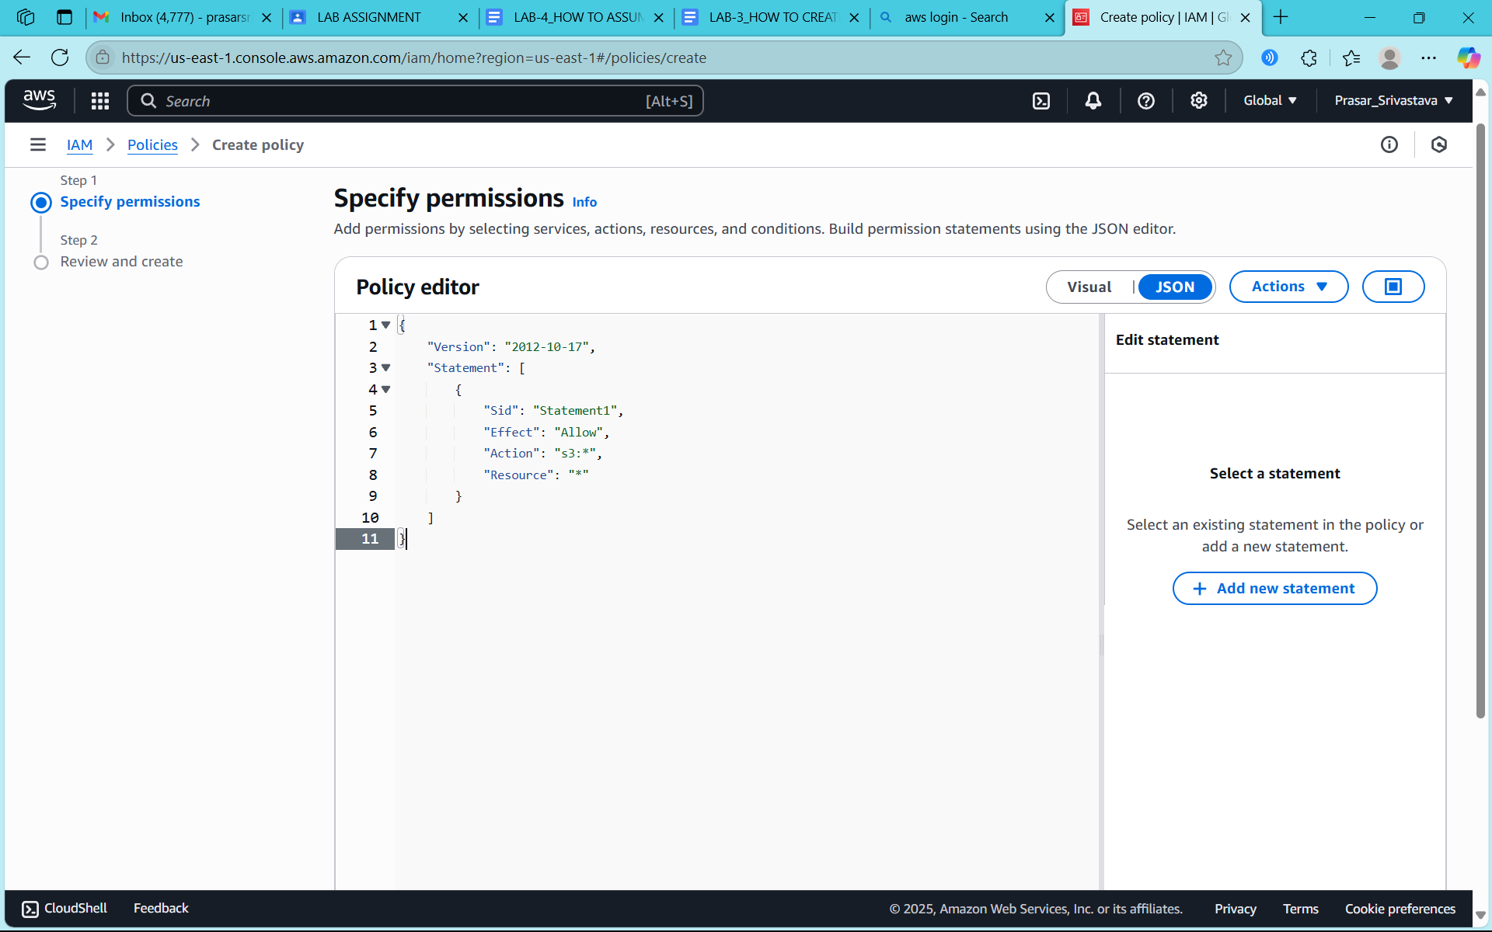

**STEP22: WRITE THE POLICY NAME**

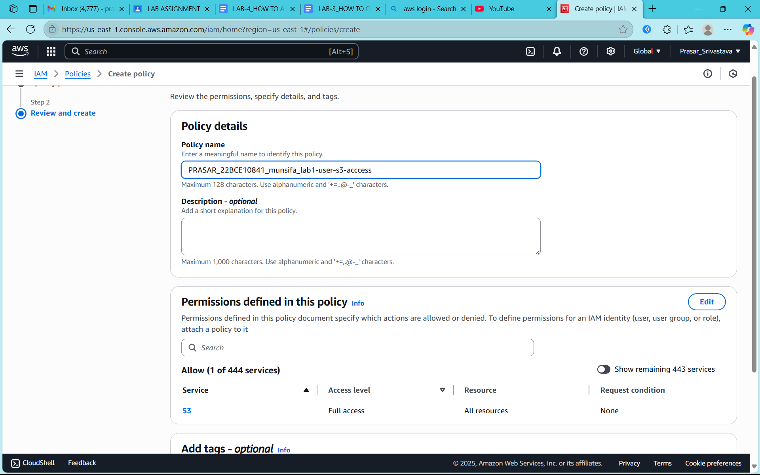

**STEP23: CLICK ON CREATE POLICY**

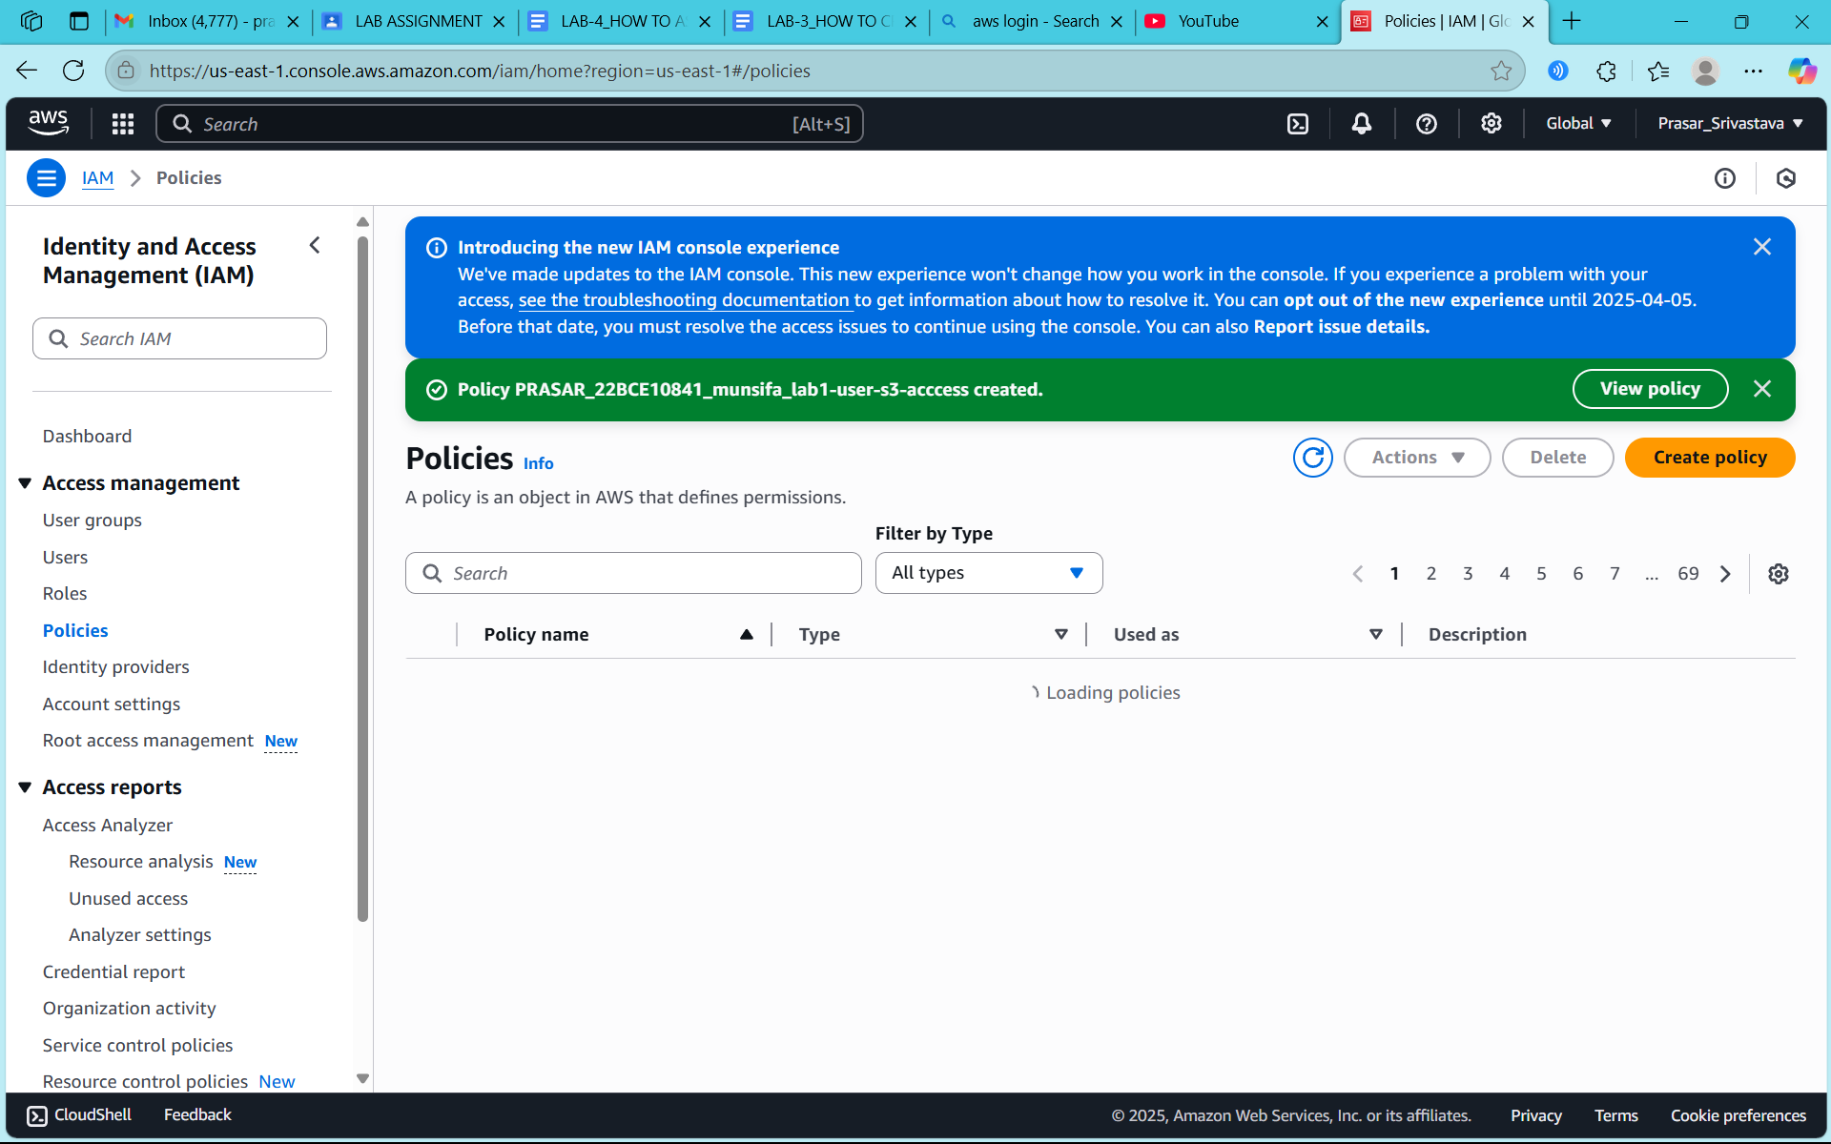

**STEP24: POLICY IS CREATED**

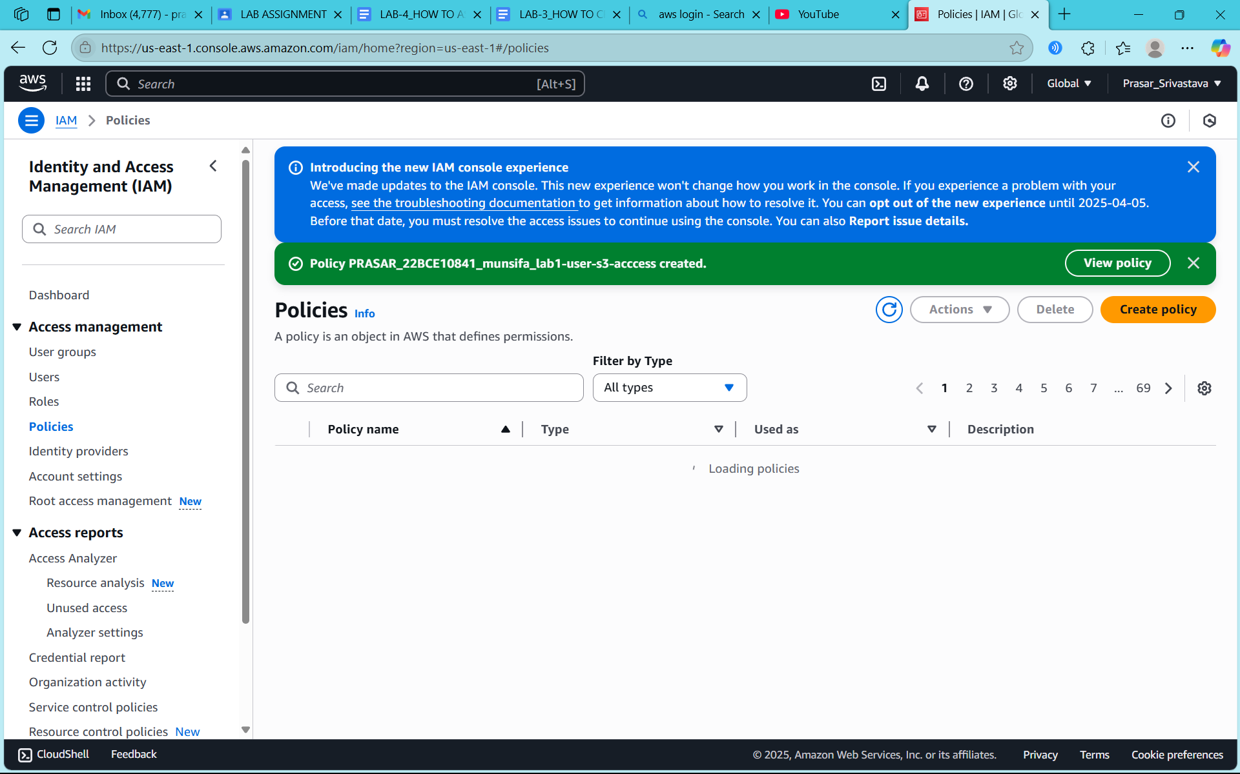

**STEP25: CLICK ON ADD PERMISSIONS**

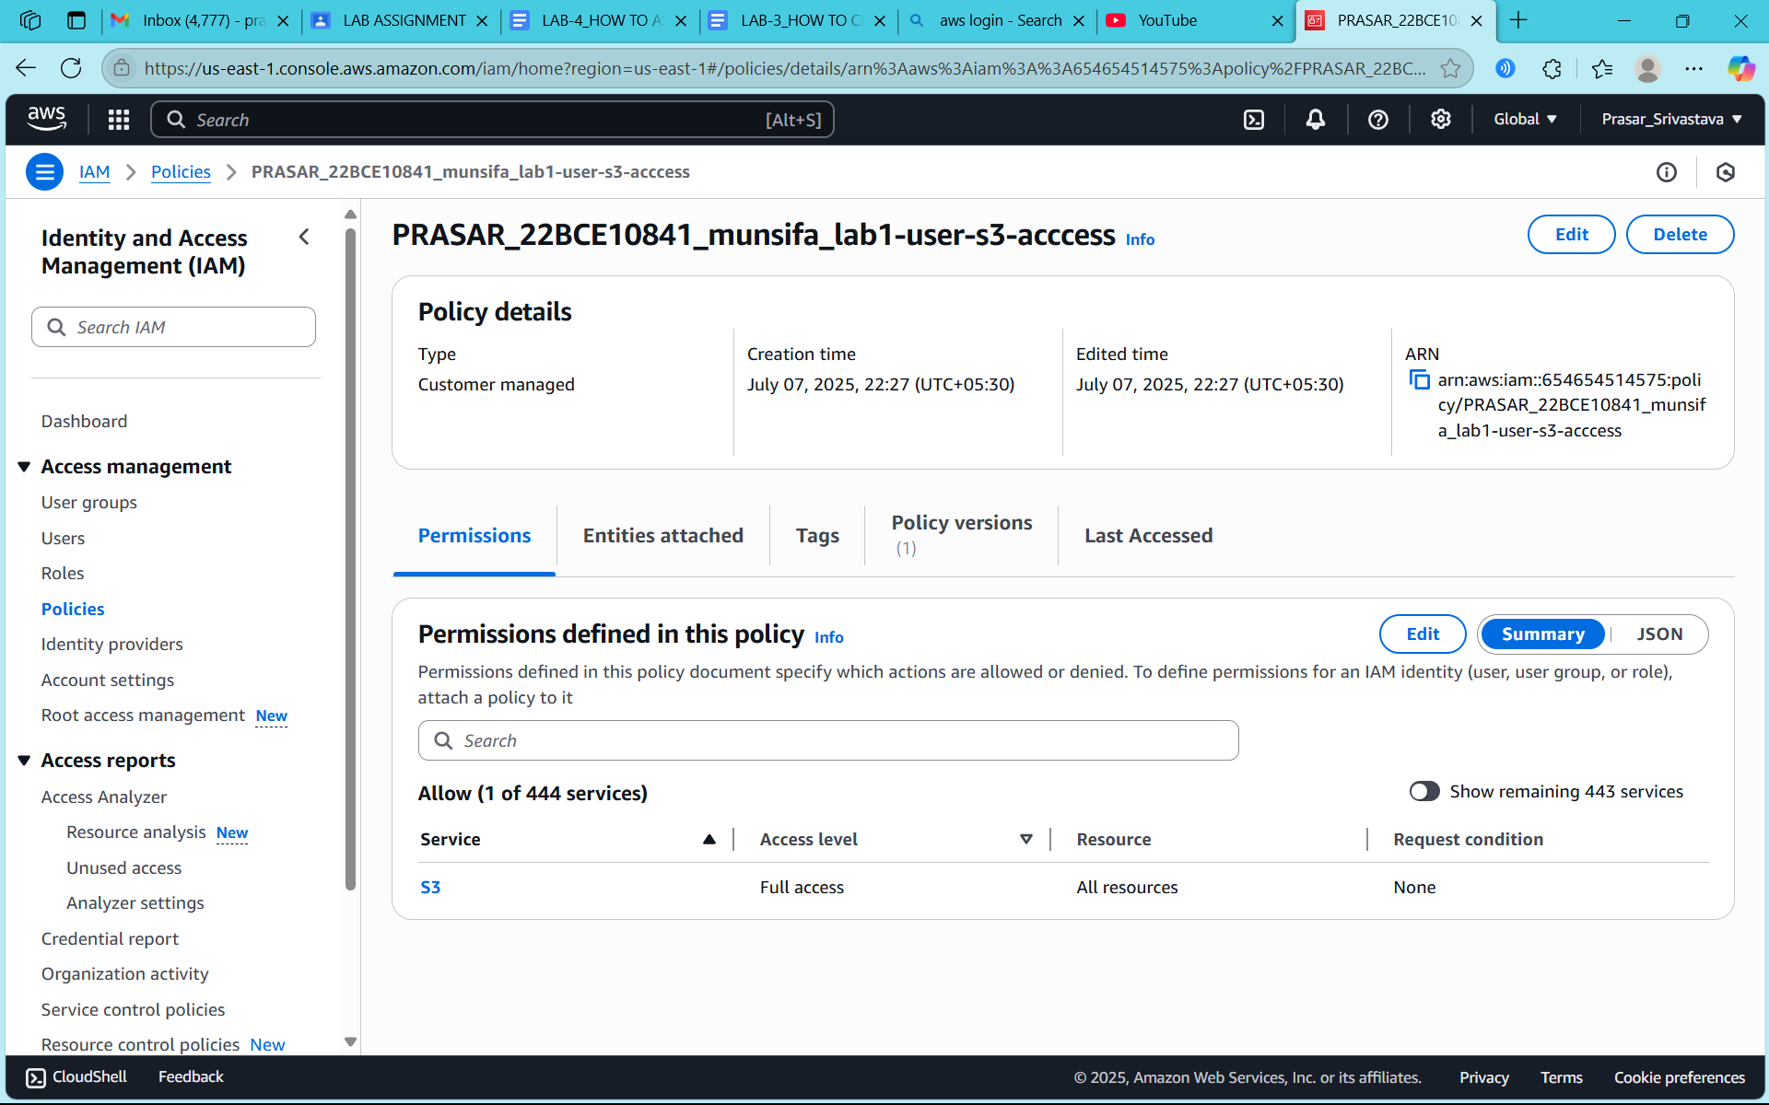

**STEP26: CLICK ON ATTACH POLICY DIRECTLY**

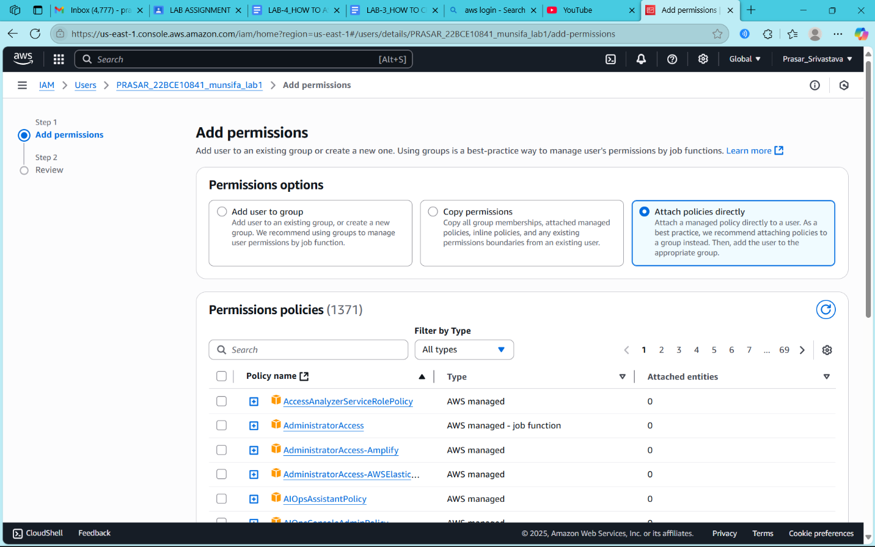

**STEP27: SEARCH FOR THE POLICY CREATED AND CLICK ON NEXT**

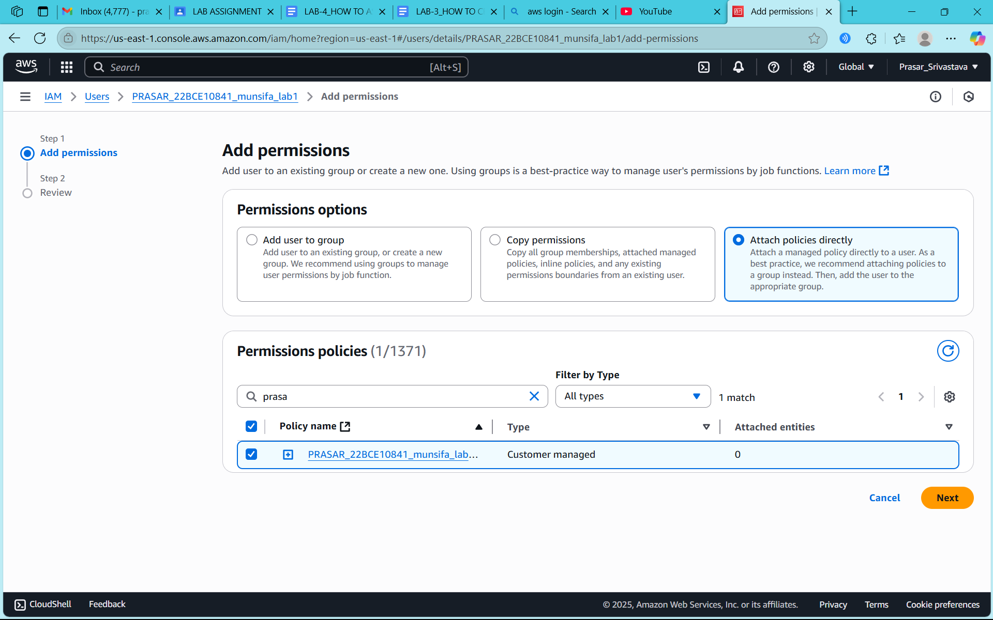

**STEP28: CLICK ON ADD PERMISSION**

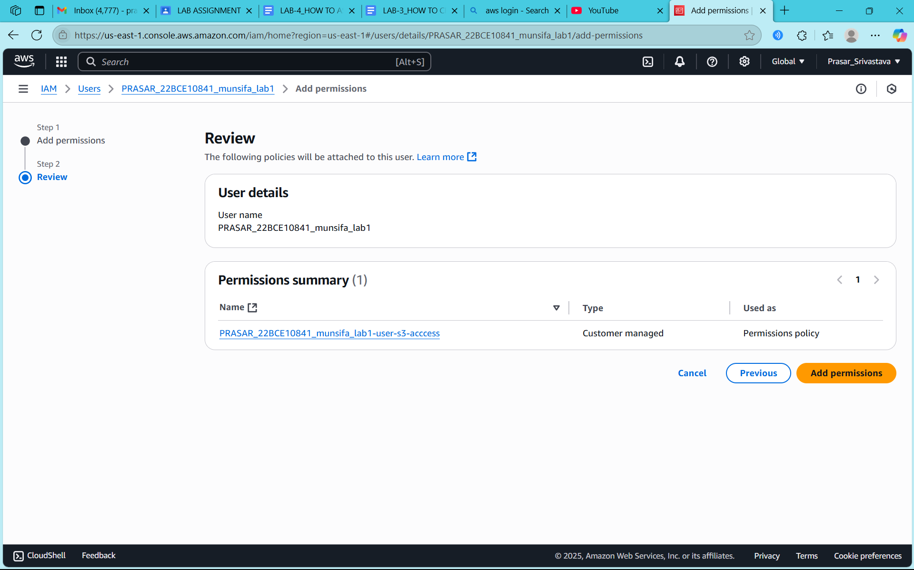

**STEP29: POLICY IS ADDED IN ROOT USER**

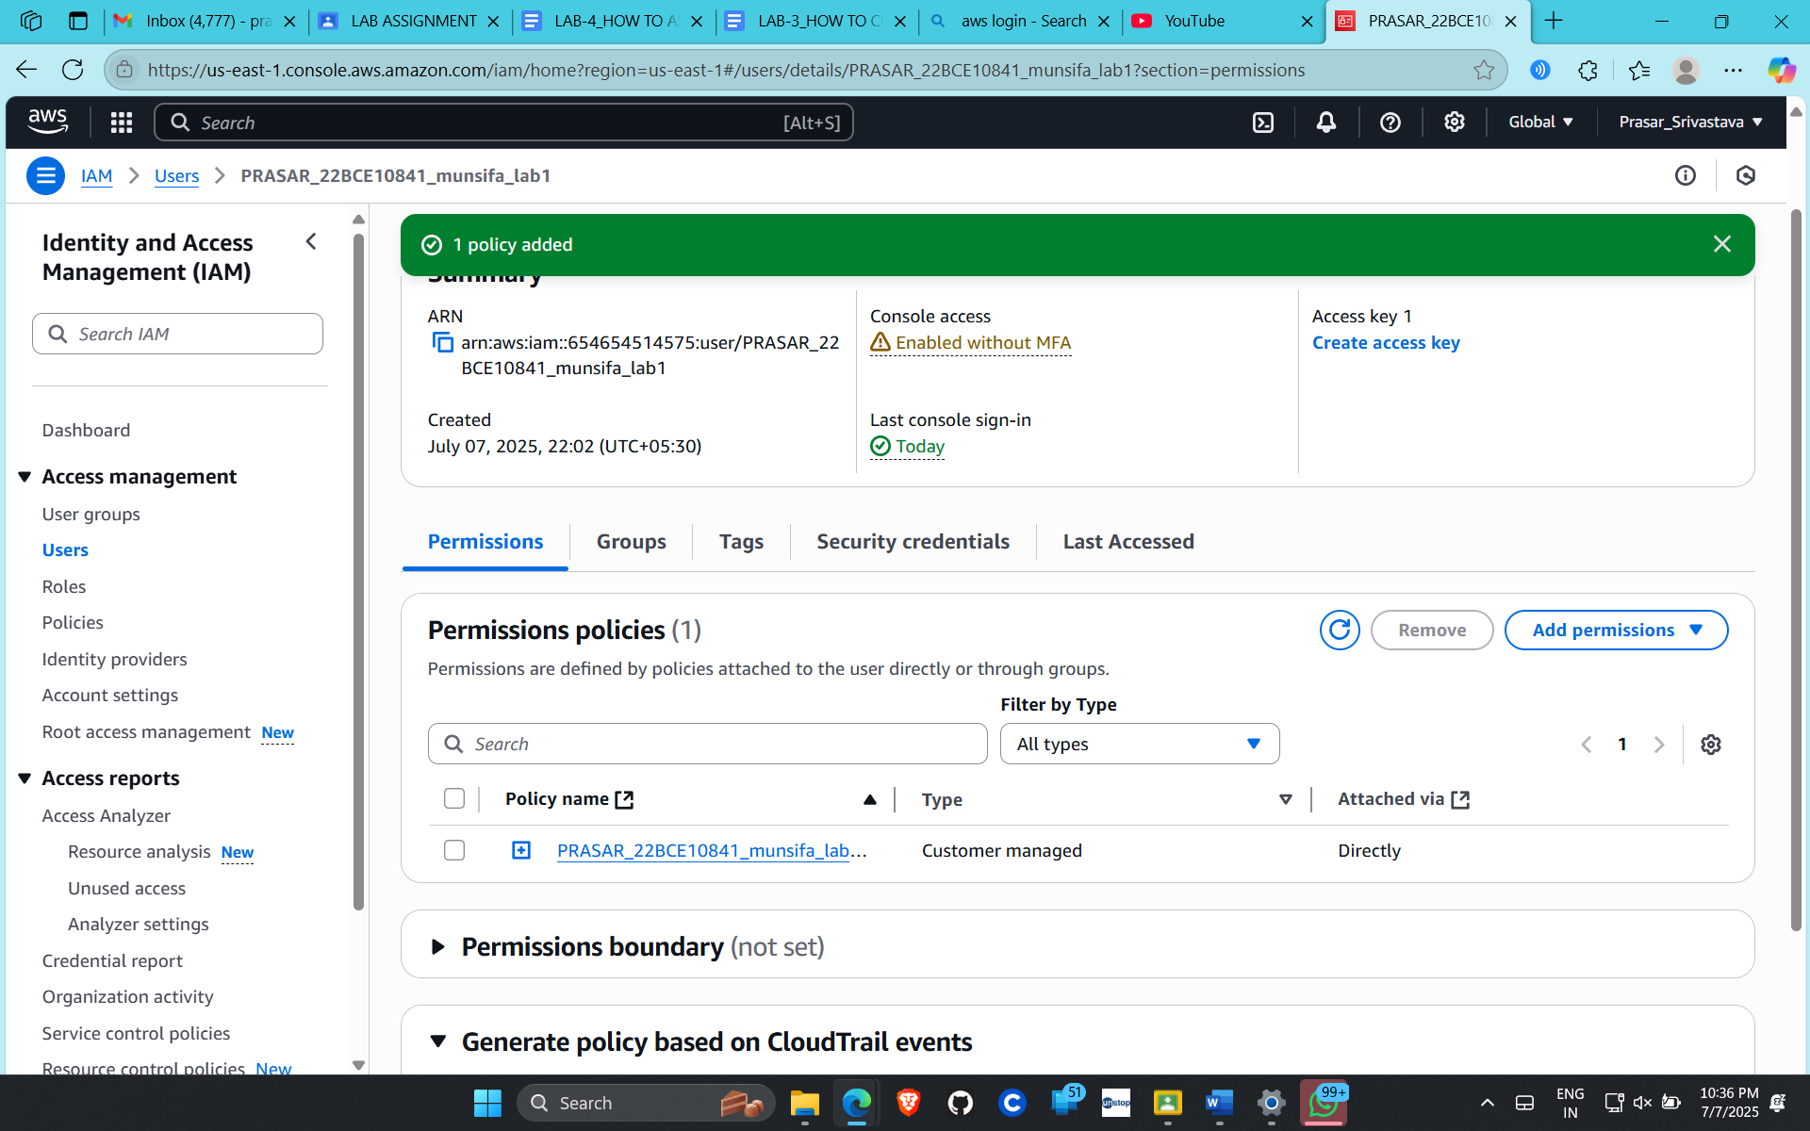

**STEP30: NOW IF YOU OPEN THE CONSOLE PAGE OF IAM USER, NO ERROR IS THERE**

